Theme
How enterprising leaders can systematically accelerate success in the age of AI

Related Topics
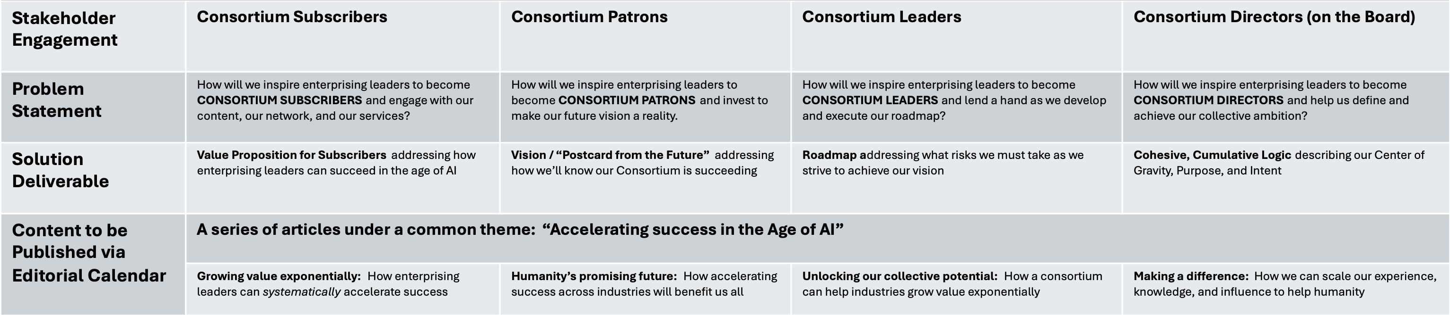

Outline

Draft

